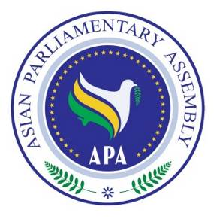
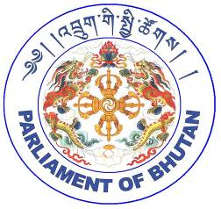

APA Standing Committee Meeting on
Social and Cultural Affairs

31 August - 2 September 2017
Thimpu – Kingdom of Bhutan

Draft Agenda
1- Adoption of the Agenda
2- Election of the Bureau
3- Opening Remarks by Chairperson
4- Report of APA Secretary General
5- Consideration and recommendation of following Draft Resolutions:

- Draft Resolution on Measures to Promote Cultural Diversity and Protect Cultural Heritage in Asia,
- Draft Resolution on Asian Integration through Information and Communication Technology,
- Draft Resolution on Collaboration on Health Equity in Asia,
- Draft Resolution on Protection and Promotion of the Rights of Migrant Workers in Asia,
- Draft Resolution on Asian Parliamentarians Against Corruption
- Draft Resolution on APA Women Parliamentarians,
- Draft Resolution on Promoting Inter- Faith Dialogue and Harmony among World Religions,
- Draft Resolution on Legal and Legislative Cooperation in Combating the Smuggling of Cultural Items in Asia,
- Draft Resolution on Effective Cooperation in Combating Illicit Drug Trafficking in Asia,
6- Any other matters.

As of 1 July 2017

